**ECE 114 Computer Assignment 2**

**Andrew Braun & Kanan Schmid**

**304 809 464 & 504 765 534**

**Abstract**

In this experiment, we will analyze the effect of filtering on speech signals. Using a pre emphasis filter, we expect that the higher frequency components of the signal with have amplified power, so we can visualize how that looks on a spectrogram, as well as compare the sounds and note any qualitative differences. Next, we will do a frequency analysis on a time domain signal of a sample voice, so as to evaluate the location of the formant frequencies. Finally, we will make time domain estimations for the fundamental frequencies, which is equivalent to the pitch period. Because we expect speech signals to have formants at frequencies that are linear multiples of the fundamental frequencies, then the period of the pseudo periodic speech wave is equivalent to the pitch period. We will try this with a male voice, a female voice, as well as our own voice, and estimate the pitch period off of the time domain signal alone.

**Questions (Part 1)**

1. Sketch three pole-zero plots for a = 0.8, 0.5, and 0.8. This can be done using the MATLAB command zplane(). The inputs are the same as in the freqz() command. Determine if each is high-pass or low-pass.
   1. See Figures 3 – 5. Highpass, highpass, lowpass for a = 0.8, 0.5, -0.8
2. Comment on the effect of pre-emphasis on the sound and in the spectrogram of the female sentence.
   1. See caption of Figure 1
      1. “Spectrogram of a filtered and unfiltered female voice. Evidently, the filtered voice contains higher power at higher frequencies according to the graph, and can especially be seen from time t = 1 to time t = 1.4 and from 0.2 to 0.4”
      2. Effect on the Sound: The sound sounds more tin-like. The filtered version also sounds higher in frequency, as expected, because there is more power at high frequencies.
3. Describe the effect of pre-emphasis on the spectrum of the steady-state
   1. See Caption of Figure 2
      1. At Steady-State, this is how both the unfiltered and filtered voices can be seen in the frequency domain. Evidently, filtering adds more power to higher frequency spectral components while attenuating lower frequency components.

**Questions (Part 2)**

1. Determine the approximate spectral locations for the first three formant frequencies.
   1. See caption for of Figure 6:
      1. “Formant Frequencies for a Male saying “/a/”. The first three formants can be observed to occur around 750 Hz, 1250 Hz, and 2400 Hz.”

**Questions (Part 3)**

1. Determine the pitch period for the “\female a" sound in samples. Determine the pitch period in seconds. (Note that the sampling rate is Fs = 8kHz.) Determine the fundamental frequency of the speaker.
   1. See the caption for figure 7.
2. Repeat the previous question for the “\male a" sound.
   1. See the caption for figure 7.
3. Now use the file rex.m to record your own voice. Running the file will prompt you to speak into your computer's microphone. If your computer does not have a microphone, you may record yourself using a smartphone, save the file to your computer, and import the audio data from the audio file as directed in the script. Say the syllable /a into the microphone for 2 seconds. The script will produce the wave form, spectrum, and spectrogram of the utterance. Use any of them to estimate your own pitch. For the waveform, you can find a segment that shows strong periodicity and estimate the period. For the spectrum, you can zoom in to estimate the distance between adjacent pitch peaks. For the spectrogram, you can estimate the distance between harmonics. You may choose your favorite method.
   1. See caption for figure 8, pitch estimated at 118.69 Hz.

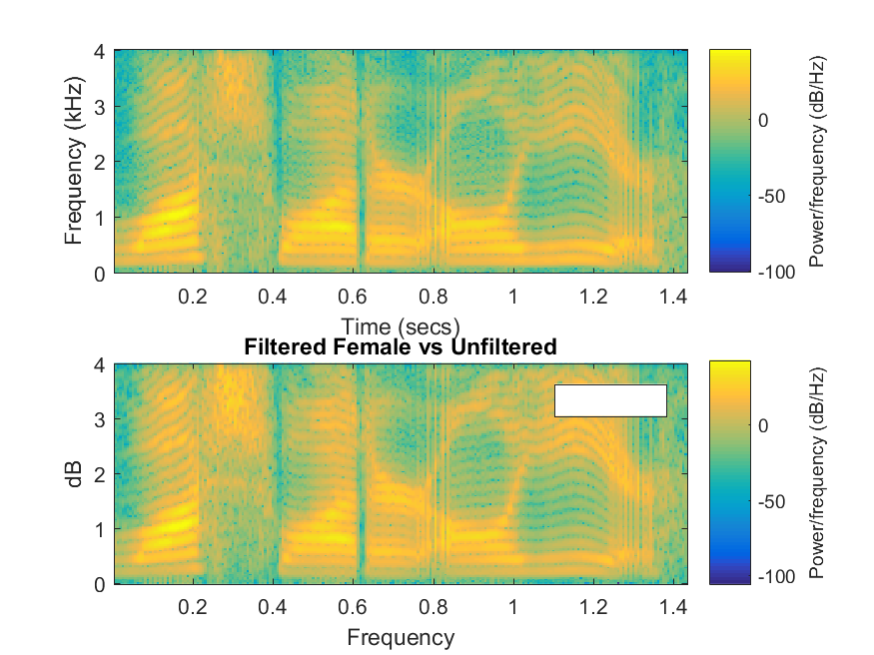

Figure 1: Spectrogram of a filtered and unfiltered female voice doing a /a/ sound. The top plot is unfiltered, and the bottom is filtered. Evidently, the filtered voice contains higher power at higher frequencies according to the graph, and can especially be seen from time t = 1 to time t = 1.4 and from 0.2 to 0.4

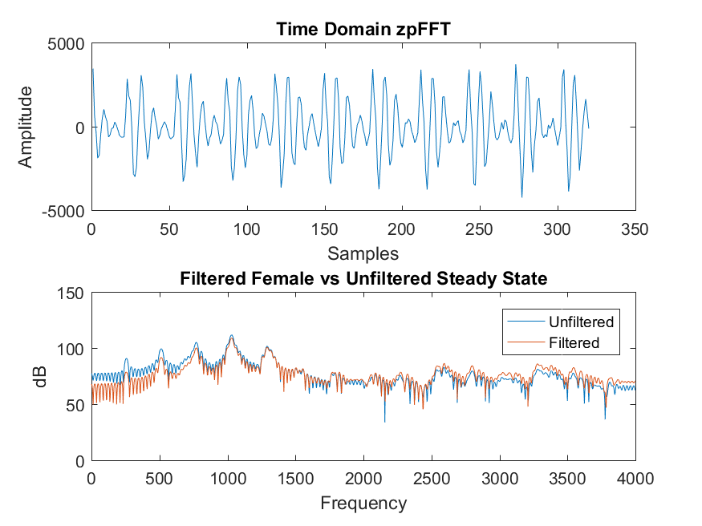

Figure 2: At Steady-State, this is how both the unfiltered and filtered voices can be seen in the frequency domain. Evidently, filtering adds more power to higher frequency spectral components while attenuating lower frequency components.

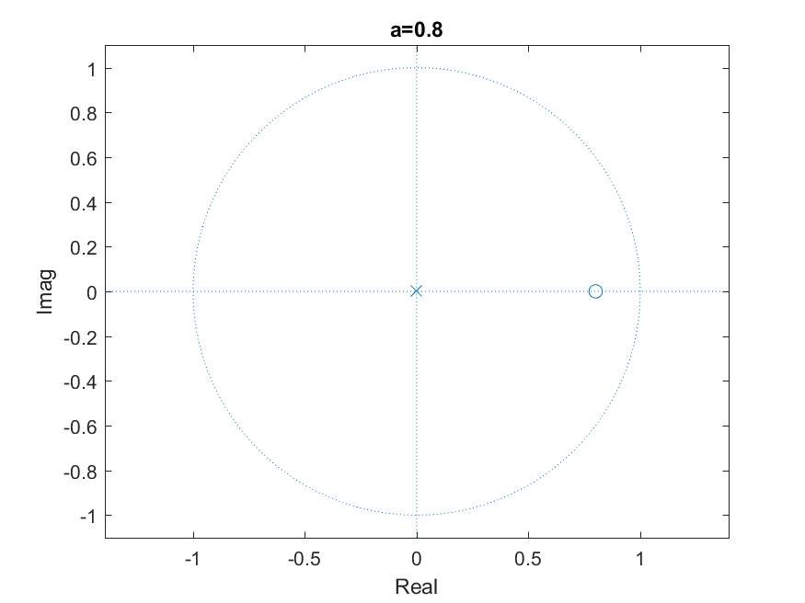

Figure 3: High-Pass Filter

Because there is a zero at zero Hz, this means low frequencies are filtered out



Figure 4: High-Pass Filter

Because there is a zero at zero Hz, this means low frequencies are filtered out

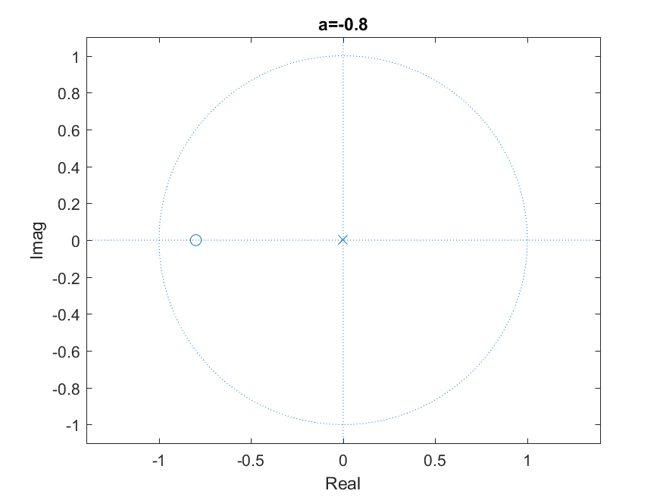

Figure 5: Low-Pass Filter

Because there is a zero at pi Hz, this means high frequencies are filtered out

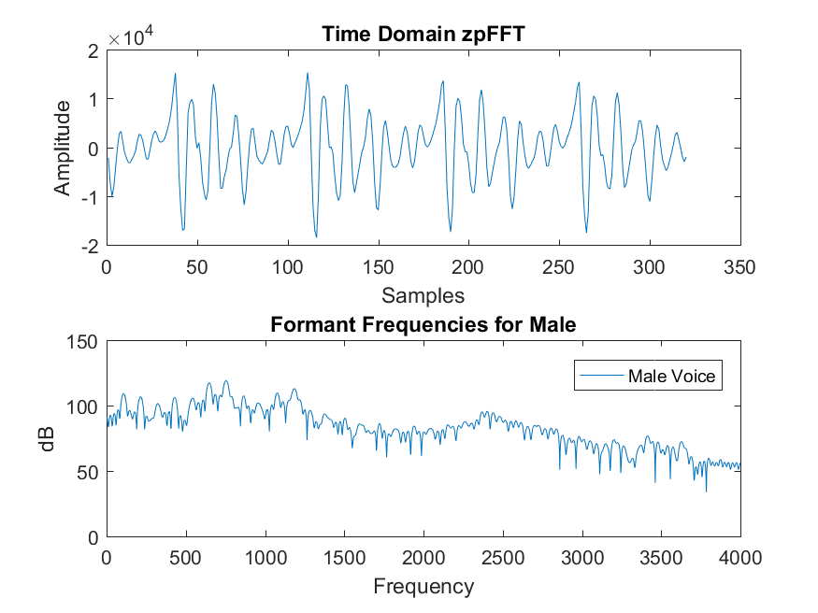

Figure 6: Formant Frequencies for a Male saying “/a/”. The first three formants can be observed to occur around 750 Hz, 1250 Hz, and 2400 Hz.

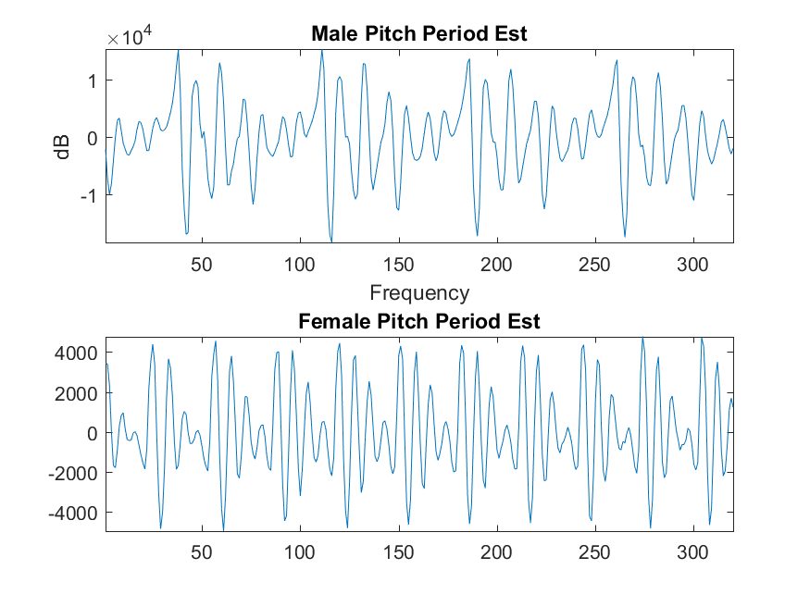

Figure 7: Pitch Period Estimates of a Female and Male saying “/a/”. The male voice seems to have a medium-low lobe at sample 150 that repeats at 223, which corresponds to a pitch period of about 73 samples. In seconds, this is: $T=\frac{Samples}{SampleRate}=\frac{73}{8000}=.009125 seconds$. This corresponds to a fundamental frequency of: $\frac{1}{T}=109.58 Hz.$ The Female voice seems to have a low lobe at 155 and 185, which is about 30 samples. In seconds, this is $T=\frac{30}{8000}=.00375 seconds$. This corresponds to a fundamental frequency of: $\frac{1}{T}=266 Hz$

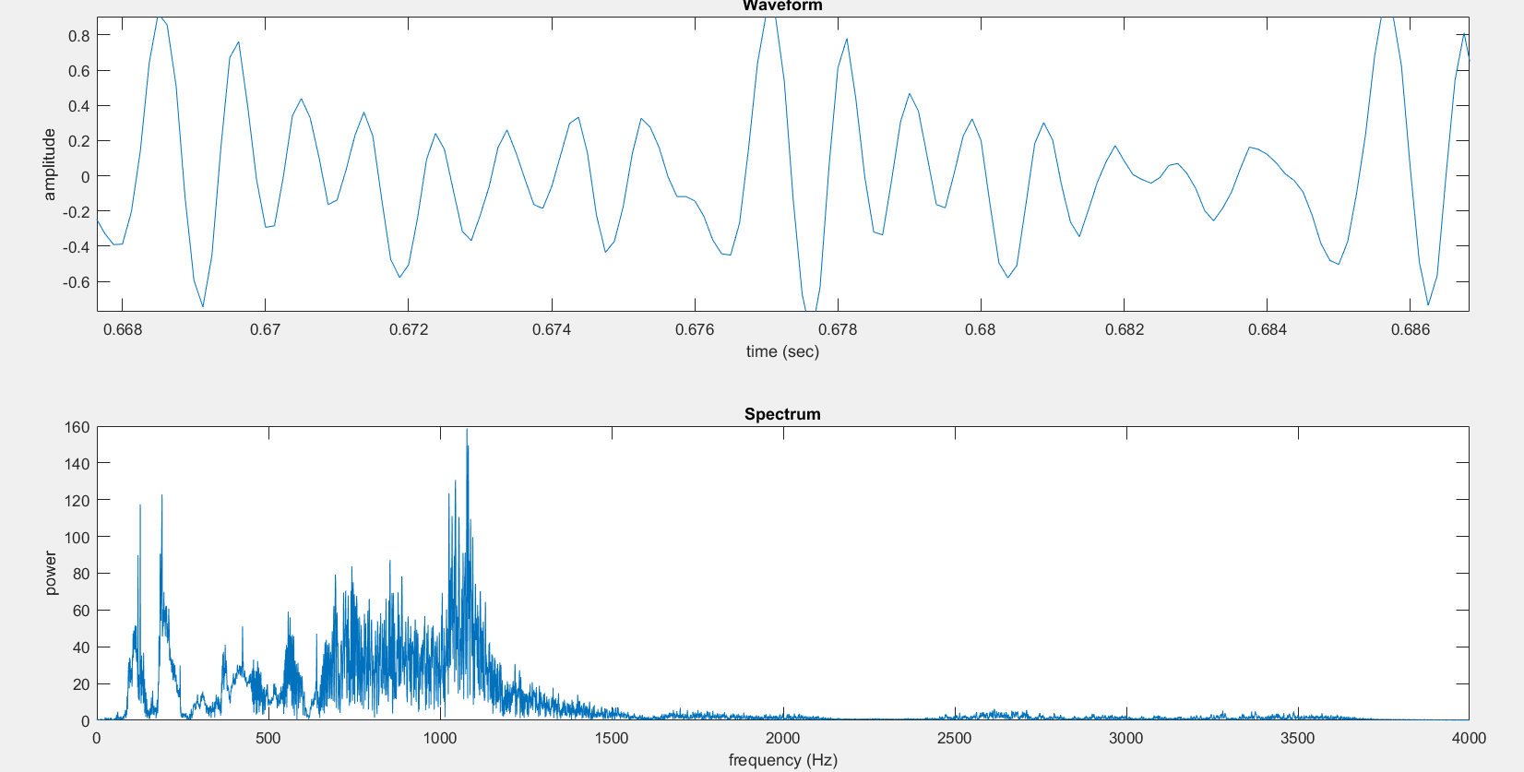

Figure 8: My own voice. There is a low-lobe at about t = 0.6692 that repeats at about t = (13/16)(0.678 – 0.676) + 0.676 = 0.67625. This corresponds to a period of 0.008425 seconds, and a fundamental frequency of $\frac{1}{T}=118.69 Hz$

Matlab code below:

